Ad hoc Networks Tutorial

1. Differentiate proactive and reactive routing protocols. Give examples.

(5 marks)

1. What is advantage of using route cache in on demand routing protocol?

(3 marks)

1. How does table-driven routing protocol work in ad hoc networks?

(4 marks)

1. Why is RouteError (RERR) message initiated in DSR routing?

(2 marks)

1. Differentiate Ad-hoc and infrastructure networks.

(4 marks)

1. How is loop free route established in table-driven and on demand routing protocols?

(3 marks)

1. Explain about each field in the table maintained at each node in using DSDV routing protocol (4 marks)
2. List the applications of Ad hoc network (4 marks)
3. Discuss how the DSR routing protocol is used to find a route from the source device (Source) to the destination (Destination), and the route maintenance procedure (6 marks)
4. What are the major reasons for TCP not performing well in Ad hoc networks?

(5 marks)

1. Consider the topology given in Figure below where Node 1 is marked as the source and Node 10 is marked as the destination. Choose ONE of the ad hoc network routing protocols to find a route from Node 1 to Node 10 (5 marks)

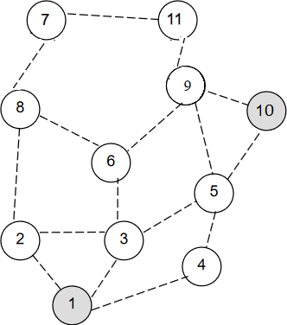

Destination

Source